Time Management System

FOR

Jayasiri Motors

Diploma in Software Engineering 22.2F

Final Project

2023



NATIONAL INSTITUTE OF BUSINESS

MANAGEMENT

Kandy Regional Center, No.02, Asgiriya road Kandy

i

W A P Fonseka KADSE222F-014

R G P Jayawardhana KADSE222F-070

U D G A Dilshara KADSE222F-051

M G D M Rajamanthree KADSE222F-073

Diploma in Software Engineering

Mr. Sandaruwan Herath

Management Information System Division,

National Institute of Business Management

“The project is submitted in partial fulfilment of the requirement of the

Diploma in Software Engineering of the National Institute of Business Management.”

December 2023

**Declaration**

“I certify that this project does not incorporate without acknowledgement, any material previously submitted for a Diploma in any institute and to the best of my knowledge and belief. It does not contain any material previously published or written by another person or by myself except where due reference is made in the text. I also hereby give consent for my project report, if accepted, to be made available for photocopying and interlibrary loans, and for the title and summary to be made available outside organizations.”

|  |  |  |
| --- | --- | --- |
| Student Name | Index No | Signature |
| W A P Fonseka | KADSE222F-014 |  |
| R G P Jayawardhana | KADSE222F-070 |  |
| U D G A Dilshara | KADSE222F-051 |  |
| M G D M Rajamanthree | KADSE222F-073 |  |

Certified by

Supervisor: Mr. Sandaruwan Herath

Signature: ………………

Date: …………………

Course Directors:

|  |  |  |
| --- | --- | --- |
| Mr. Sandaruwan Herath |  | Ms. Inoka Abhayasinghe |
| Signature: ……………. |  | Signature: ……………. |
| Date: ………………… |  | Date: ………………… |

**Abstract**

Jayasiri Motors is launching a groundbreaking website to transform the vehicle service industry through digital innovations. Recognizing the importance of efficient time management, the company is dedicated to improving operational effectiveness. The project aims to address service-related challenges by reducing turnaround times and enhancing customer satisfaction. Key features include an online appointment system to minimize waiting times and a centralized communication platform for real-time updates, promoting transparency. The initiative envisions a future where customers can easily access online appointments, optimizing service station resources and redefining the vehicle service experience at Jayasiri Motors.

Table of Contents

Declaration III

Abstract IV

Table of Contents Vi

## List of Figures

Figure 1 Organization Structure…………………………………………………….1

Figure 2: Current Operations in Organization……………………………………….2

Figure 3: Users and Responsibilities Organization……………………………….….2

Figure 4: Problem Definition…………………………………………………….…..3

Figure 5: Project Objectives………………………………………………….………3

Figure 6: Proposed Solution………………………………………………….………3

Figure 7: Chapter Summery………………………………………………….………4

Figure 8: Methology………………........................................................................... 5

Figure9: Introduction………………………………………………………….……..5

Figure10: DataCollectionMethod(s)………………………………………….……...5

Figure 11: Software Process Model……………………………………………….....5

Figure 12: Software Development Tools………………………………………….....6

Figure 13: Testing Strategies………………………………..………………….……6

Figure 14: Implementation Plan…………………………………………...…….…...6

Figure 15: Chapter Summery………………………………………………….……...6

Figure 16: Analysis…………………………………………………………………...8

Figure 17: Introduction………………………………………………………….……8

Figure 18: UML Diagram…………………………………………………….………8

Figure 19: Use Case Diagram of Current System…………………………………….9

Figure 20: Use Case Diagram of Proposed System…………………………….….10

Figure 21: Class Diagram of Proposed System..................................................…...11

Figure 22: Sequence Diagrams (Each Use case) for Proposed System..............…...13

Figure 23: ER Diagram of the Proposed System……………………………...……15

Figure 24: Chapter Summery…………………………………………………..…...16

Figure 25: Solution Design …………………………………………………...……17

Figure 26: Introduction………………………………………………………...…...17

Figure 27: Interface Design…………………………………………………...……17

Figure 28: Database Design……………………………………………………...…21

Figure 29: Report Layout Design………………………………………………......21

Figure 30: Conclusion………………………………………………………….…..21

Figure 31: References……………………………………………………………...24

Figure 32: Appendices……………………………………………………………..25

## List of Tables

**Chapter 1: Introduction**

1.1 Introduction of the Organization…………………………………………..1

1.2 Organization Structure…………………………………………………….1

1.3 Current Operations in Organization……………………………………….2

1.4 Users and Responsibilities Organization………………………………….2

1.5 Problem Definition………………………………………………………..3

1.6 Project Objectives…………………………………………………………3

1.7 Proposed Solution…………………………………………………………3

1.8 Chapter Summery…………………………………………………………4

**Chapter 2: Methodology**

2.1 Introduction………………………………………………………………..5

2.2 Data Collection Method(s)………………………………………………...5

2.3 Software Process Model…………………………………………………...5

2.4 Software Development Tools………………………………………….…..6

2.5 Testing Strategies…………………………………………………….……6

2.6 Implementation Plan………………………………………………….…...6

2.7 Chapter Summery………………………………………………….……...6

**Chapter 3: Analysis**

3.1 Introduction………………………………………………………….……8

3.2 UML Diagram…………………………………………………….………8

Use Case Diagram of Current System

Use Case Diagram of Proposed System

Class Diagram of Proposed System

Sequence Diagrams (Each Use case) for Proposed System

3.3 ER Diagram of the Proposed System…………………………………15

3.4 Chapter Summery……………………………………………………..16

**Chapter 4: Solution Design**

4.1 Introduction…………………………………………………………...17

4.2 Interface Design………………………………………………………17

4.3 Database Design………………………………………………………21

4.4 Report Layout Design………………………………………………...21

**Chapter 5: Conclusion…………………………………………………………..21**

**Chapter 6: References…………………………………………………………...22**

**Appendices………………………………………………………...……………..23**

Table1: Project Plan……………………..………………………………..23

Project plan

Source code

# Chapter 1

INTRODUCTION

* 1. Introduction of the Organization

Jayasiri Motors is launching a specialized website to revolutionize the vehicle service industry by leveraging digital advancements. Recognizing the significance of effective time management in the rapidly evolving landscape of maintenance, the company is committed to streamlining processes and enhancing overall operational efficacy. The project aims to address existing service-related challenges, with a primary focus on reducing turnaround times and augmenting customer satisfaction. Key features of the initiative include an online appointment scheduling system, which aims to minimize waiting periods, and a centralized communication platform that provides real-time updates, fostering transparency. This endeavor envisions a future where customers can effortlessly access online appointments, optimizing the utilization of service station resources and redefining the vehicle service experience at Jayasiri Motors.

1.2 Organization Structure

The organizational framework of Jayasiri Motors has been strategically designed to facilitate its objective of enhancing vehicle service through digital innovation. Spearheaded by the executive leadership, which includes the CEO, COO, and CIO, various key departments such as Operations, Customer Experience, and Technology collaborate closely. Within these departments, teams are dedicated to optimizing time management, implementing online services, and overseeing digital initiatives. To ensure seamless communication between service providers and customers, a centralized communication team is responsible for providing real-time updates, thereby promoting transparency. Additionally, support functions, quality assurance, and future development teams play a vital role in enhancing the overall efficiency and effectiveness of Jayasiri Motors. This organizational structure has been tailored to align with the organization's goals of enhancing customer satisfaction, streamlining processes, and embracing innovative technologies.

* 1. Current Operations in Organization

Jayasiri Motors currently operates with a focus on routine vehicle maintenance, quality assurance, and customer service facilitated by representatives. The organization acknowledges challenges in time management, affecting customer satisfaction and overall productivity. While a dedicated website project is in progress, the existing digital presence includes basic online information. Internal communication channels and technology infrastructure are in place, with ongoing efforts to address operational challenges and plan for future development. Financial operations are managed through budgeting, and the organization is aware of the need for innovation in its operations.

1.4 Users and Responsibilities Organization

At Jayasiri Motors, the user and responsibilities organization is structured to include customer users, internal teams (service providers, customer service representatives, and IT department), executive leadership (CEO, COO, and CIO), support functions (HR manager, finance manager), quality assurance teams, communication managers, and an innovation and development team. Each group has defined responsibilities contributing to the overall efficiency, customer satisfaction, and success of the organization.

1.5 Problem Definition

The primary challenge faced by Jayasiri Motors centers around inefficient time management within its current operations. This issue has direct implications for customer satisfaction, operational productivity, and communication effectiveness. Additionally, the organization recognizes limitations in its existing digital infrastructure, particularly in the context of appointment scheduling inefficiencies. The overall objective is to address these challenges by optimizing time management through the implementation of a dedicated website and digital solutions, aiming to enhance customer satisfaction and overall operational efficiency.

1.6 Project Objectives

The project objectives for Jayasiri Motors are focused on optimizing time management and enhancing operational efficiency through the implementation of digital solutions. Key goals include reducing turnaround times, improving service delivery, establishing a user-friendly website, implementing online appointment scheduling, and creating a centralized communication platform. The project also aims to optimize resource utilization, streamline administrative processes, enhance the organization's digital presence, foster innovation, and promote transparency and accountability. These objectives collectively aim to elevate customer satisfaction and position Jayasiri Motors for sustained success in the automotive service industry

1.7 Proposed Solution

The proposed solution for Jayasiri Motors involves the implementation of a comprehensive digital platform to address identified challenges and achieve project objectives. Key elements include the development of a user-friendly website, an online appointment scheduling system, and a centralized communication platform. Digital tools for administrative processes, employee training, continuous improvement, cybersecurity measures, customer education, and a comprehensive marketing strategy are integral components. This holistic approach aims to revolutionize operational processes, optimize resource utilization, enhance customer experience, and position Jayasiri Motors as a leader in efficient and customer-centric vehicle service.

1.8 Chapter Summery

In this chapter, we delved into the challenges faced by Jayasiri Motors, focusing on time management issues impacting customer satisfaction and operational efficiency. The chapter introduced a project aiming at digital transformation for operational excellence. The problem definition underscored the critical areas requiring attention, leading to the project's objective: optimizing time management through a dedicated website and digital solutions. The proposed solution outlined a comprehensive roadmap, encompassing website development, online scheduling, centralized communication, digital tools, employee training, continuous improvement, cybersecurity, customer education, and a marketing strategy. This holistic approach aims to revolutionize operational processes, fostering efficiency and customer-centricity, positioning Jayasiri Motors as an industry leader in vehicle service.

**Chapter 2**

Methodology

2.1 Introduction

Jayasiri Motors, a key player in the automotive service industry, is embarking on a digital transformation journey to optimize time management, enhance customer satisfaction, and improve operational efficiency. Recognizing the significance of these objectives, this research initiative is introduced with a focus on leveraging cutting-edge technologies tailored to the specific challenges faced by the organization. The journey involves exploring the problem landscape, refining objectives, and implementing a comprehensive methodology to guide the successful implementation of digital solutions. This transformative endeavor aims to position Jayasiri Motors at the forefront of operational excellence within the competitive automotive service sector.

2.2 Data Collection Method(s)

* + Surveys and Questionnaires
  + Interviews
  + Focus Group Discussions
  + Observation and Process Mapping
  + Technology Assessment
  + Customer Usage Analytics

2.3 Software Process Model

The recommended software process model for Jayasiri Motors' digital transformation project is the Agile Software Development Model. This choice is driven by its iterative and incremental development approach, flexibility, emphasis on customer collaboration, formation of cross-functional teams, and delivery of frequent and tangible increments, focus on continuous improvement, effective risk management, transparent communication, commitment to quality assurance, and the ability to ensure a faster time-to-market for digital solutions. The Agile model aligns with the dynamic and customer-centric nature of the project, facilitating adaptability and efficient collaboration for successful implementation.

2.4 Software Development Tools

For our client’s application we decided to build it using C# and we used Visual Studio IDE as the development environment.

And for the students’ website, we decided to build it using HTML, CSS, and PHP, also we used Visual Studio Code as development environment.

HTML

CSS

JavaScript

MySQL

LARAVEL

2.5 Testing Strategies

* Unit Testing
* Integration Testing
* Functional Testing
* Performance Testing
* Security Testing
* Regression Testing
* Usability Testing
* Compatibility Testing
* Data Integrity Testing
* Continuous Testing
  1. Implementation Plan
* The implementation plan for Jayasiri Motors' digital transformation project involves the following key steps:
* Requirements Finalization
* Technology Stack and Tools Setup
* Agile Sprint Planning
* Development and Coding
* CI/CD Setup
* Iterative Testing
* Stakeholder Feedback
* User Training
* Pilot Testing
* Full Deployment
* Monitoring and Optimization
* Continuous Improvement
  1. Chapter Summery

The chapter outlines a comprehensive plan for Jayasiri Motors' digital transformation project. Starting with a project kickoff and requirements finalization, it covers the setup of technology and tools, embracing agile development with iterative sprints. The coding phase includes continuous integration and deployment, with rigorous testing and stakeholder engagement. User training and a pilot test precede full deployment. Post-implementation, the focus shifts to monitoring, optimization, documentation, and knowledge transfer. The chapter concludes by emphasizing continuous improvement through retrospectives and feedback mechanisms, ensuring Jayasiri Motors remains operationally excellent in the realm of digital transformation.

**Chapter 3**

Analysis

3.1 Introduction

The introduction outlines the section's focus on analyzing the problem landscape for Jayasiri Motors' digital transformation. The main subheadings include evaluating the current system, assessing stakeholder needs, conducting SWOT and gap analyses, technology assessment, regulatory compliance review, and analyzing customer feedback. The goal is to comprehensively understand existing challenges and opportunities, setting the stage for informed decision-making and the formulation of effective digital solutions.

3.2 UML Diagram

* DFD Diagram

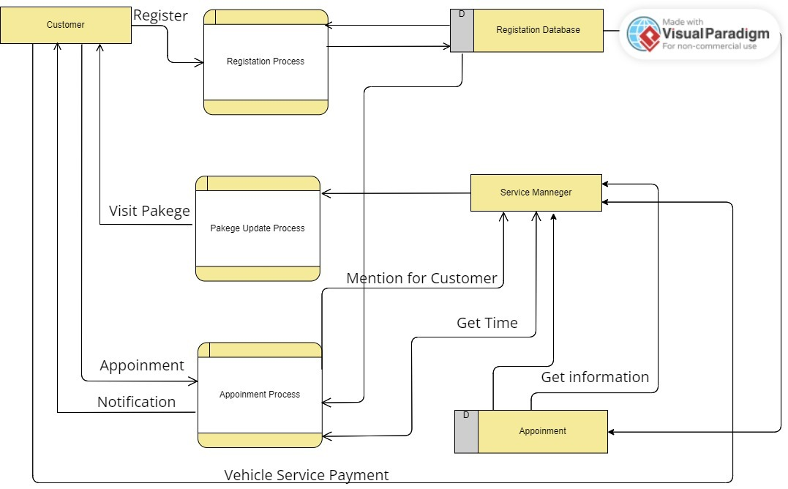

Figure 1: DFD Diagram

Explanation

The system enables customers to undergo a seamless process that includes registration, package updates, and appointment scheduling. Following the registration, the system proceeds to the update process to ensure that customer details are current. Subsequently, customers gain access to available packages, enabling them to select their desired package and proceed to book an appointment. Upon booking, customers receive a notification confirming their appointment. Meanwhile, the service manager can access the database, retrieve vehicle payment details, and view appointment times for customers. Finally, the service manager updates the database to maintain accurate and up-to-date information.

Use Case Diagram

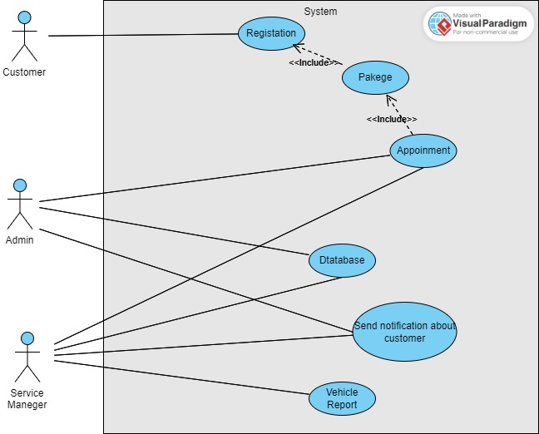

Figure 2: Use Case Diagram

Explanation

In this system have two main actress they are customer and service manager. Customer have several attributes they are new user registration, select packages, get appointment. And service manager have database, notification and vehicle report. Service manager can access appointment as well using this access service manager can entered data to database.

### Context Diagram

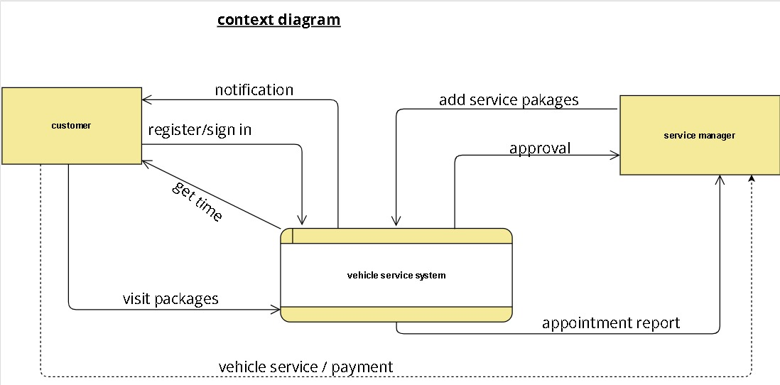

Figure 3: Context Diagram

Explanation

This paragraph provides an overview of the context diagram for the Jayasiri service station project. The system allows the service manager to add service packages to the vehicle service system. After adding a service package, the manager seeks approval from the system. When a customer makes an appointment, the system automatically sends an appointment report to the manager. Customers have the capability to register on the system, explore available service packages, schedule appointments, and receive notifications containing appointment details. Additionally, customers can make payments directly to the service manager through the system. This context diagram outlines the key interactions and functionalities within the project

* Sequence Diagram

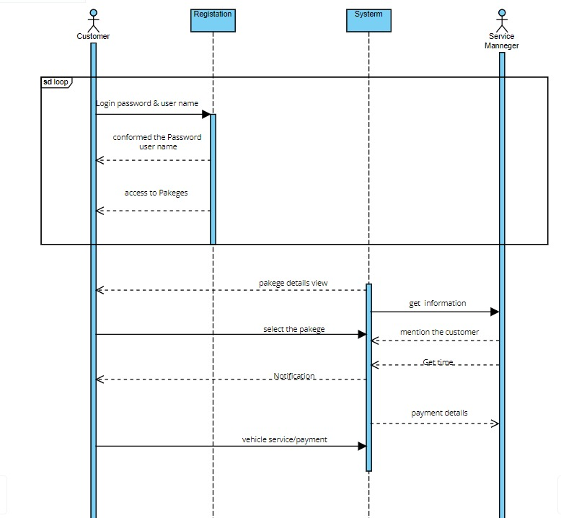

Figure 4: Sequence Diagram

Explanation

In this sequence diagram, the customer initiates the interaction by logging into the system with a provided username and password. Once logged in, the customer gains access to a range of service packages and selects the preferred option. Following the selection of a package, the customer proceeds to create an appointment. At this point, crucial information about the chosen package is transmitted to the service manager. Upon receiving this data, the service manager takes action by assigning a specific date and time for the service. The system then promptly sends a notification to the customer, detailing the scheduled date and time for the service appointment.

As the customer receives the service at the designated time, they subsequently engage in the payment process through the system. The payment details are then transmitted to the service manager, confirming the successful completion of the transaction. This sequential flow highlights the orchestrated interactions between the customer, the system, and the service manager throughout the stages of accessing service packages, making appointments, receiving notifications, and finalizing the payment process.

Class Diagram of Proposed System

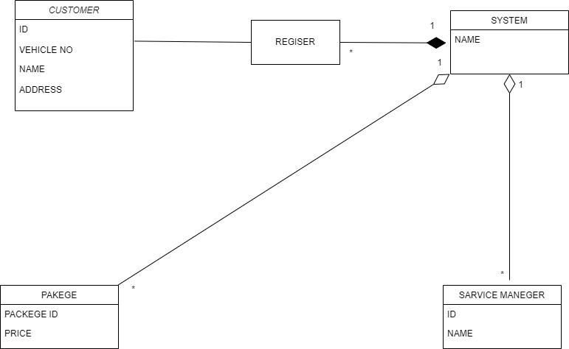

Figure 5: Class Diagram

Explanation

This is the class diagram for the system. Customer entity contains attributes like customer ID, vehicle number, customer name and address. First the customer registers to the system. Then the customer can select the package they prefer. When they select a package the information about the package will be sent to the service manager. Then the manager will decide the date and time for the appointment and send a notification to the customer

3.3 ER Diagram of the Proposed System

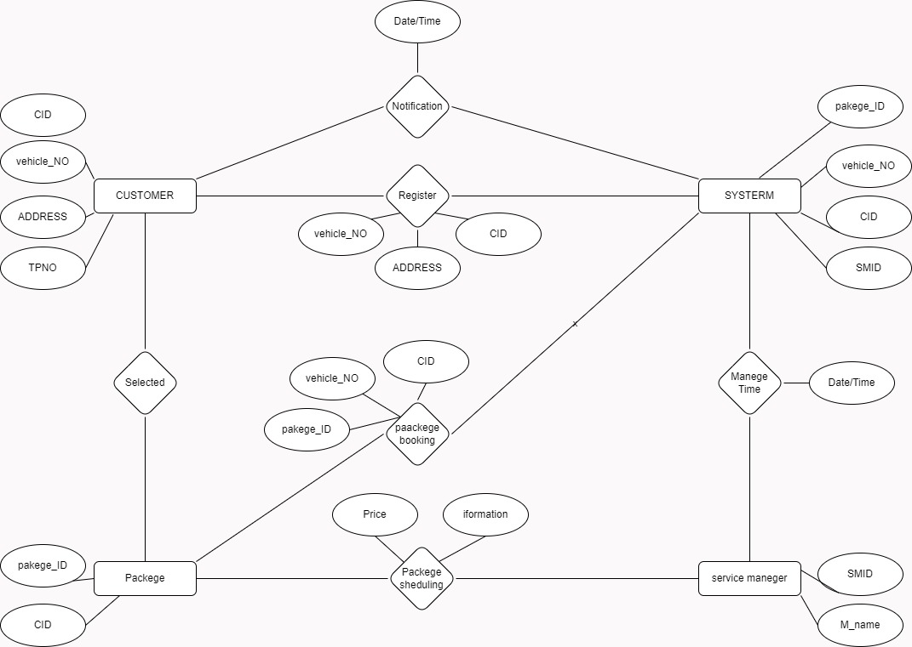

1

1

1

1

N

1

N

1

N

1

1

N

Figure 6: ER Diagram

Explanation

The customer is characterized by several attributes, including customer ID, vehicle number, address and the telephone number. The system entity possesses attributes like package ID, vehicle number, customer ID and service manager ID.to access the service station, customer is required to log in with their credentials to the system. And the package entity has two attributes, and they are package ID and the customer ID. Within the system, customers have the capability to select the packages they prefer. When a customer selects a package and book the package, the information about the package will be sent to the service manager by the system. And the service manager will decide the date and time to do the service. And the system sends a notification containing the date and time to do the service customer requires.

3.4 Chapter Summery

The chapter focuses on analyzing the problem landscape for Jayasiri Motors' digital transformation, utilizing various UML diagrams and analytical tools. It begins with Use Case Diagrams illustrating the current and proposed systems, transitioning into a Class Diagram for structural insights. Sequence Diagrams break down user interactions in the proposed system, while an ER Diagram provides a visual representation of data relationships. The chapter's purpose is to comprehensively understand challenges and opportunities through stakeholder needs assessment, SWOT analysis, gap analysis, technology assessment, regulatory compliance review, and customer feedback analysis. It sets the stage for well-informed decision-making and the formulation of effective digital solutions, serving as the intellectual foundation for the subsequent phases of Jayasiri Motors' digital transformation.

**Chapter 4**

Solution Design

4.1 Introduction

The introduction sets the stage for the Solution Design section, emphasizing the critical role of a well-crafted solution in Jayasiri Motors' digital transformation. It highlights the convergence of strategic thinking and technological innovation to create an optimized and responsive digital framework. The section aims to unfold the intricacies of the proposed solution's design, outlining how each component contributes to the overarching vision of operational excellence and enhanced customer satisfaction.

4.2 Interface Design

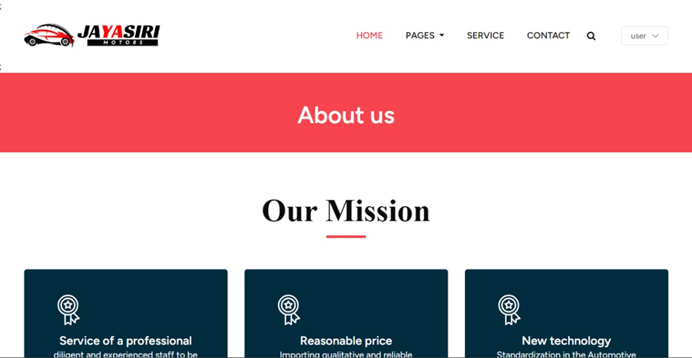

Figure 7: About us page

START

If click About Us

Load About us page

Else if click Contact

Load Contact us page

Else if click page

Load page

Else if click service

Load services

End if

END



Figure 8: Home Page

START

Else if click Contact

Load Contact us page

Else if click page

Load page

Else if click service

Load services

End if

END

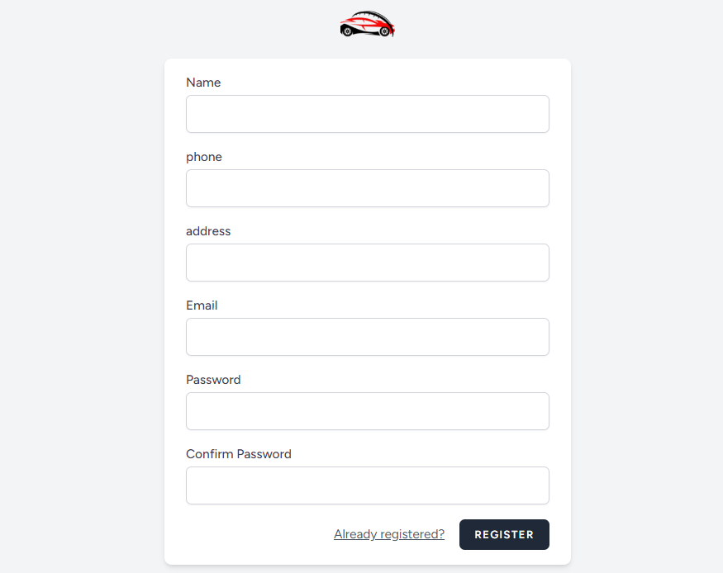

Figure 9: Registration page

If click Register

Load Register window

Enter Username;

Enter Email;

Enter Address;

Enter Telephone;

Enter Password;

If Username == null

Display “ Enter name” If Email == null

Display “ Enter email” If Address == null

Display “ Enter Address”

If Telephone == null

Display " Enter Telephone”

If passwords == null

Display “ Enter Correct Password"

End if

End if

End if

End if

End if

Click Register Button

If all fields are filled

Register user

End if

End if

END

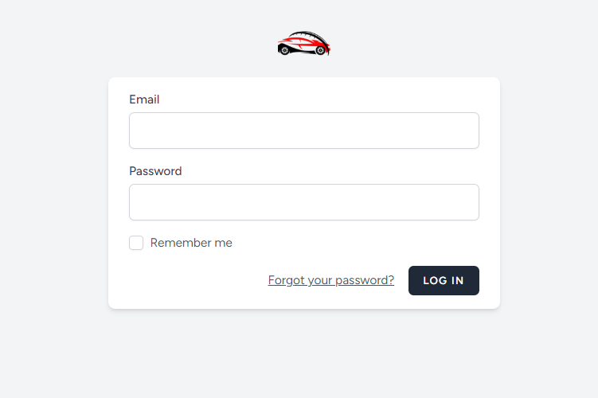

Figure 10: login page

START

Enter Username

Enter Password

If Username == null

Display “Fill all the fields “

If Username == null

Display "Fill all the fields "

End if

End if

Click login

If click login button

Login to web page

If password is incorrect

Display “ Failed to login”

End if

End if

END

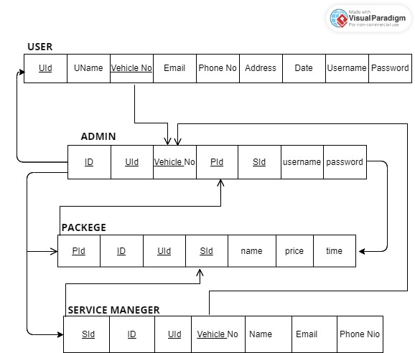4.3 Database Design

Figure 11: Database Schema

**Chapter 5**

Conclusion

In conclusion, the exploration of the challenges faced by Jayasiri Motors and the proposed digital transformation project highlights the organization's commitment to addressing critical issues related to time management, customer satisfaction, and operational efficiency. By embracing cutting-edge technologies and innovative solutions, Jayasiri Motors demonstrates a proactive approach to remaining competitive in the fast-paced automotive service industry. The identification of time management problems and the limitations of the current digital infrastructure have paved the way for a comprehensive project with well-defined objectives. The proposed solution, which includes the development of a user-friendly website, an online appointment scheduling system, and a centralized communication platform, presents a holistic strategy to overcome these challenges. The methodology outlined in Chapter 2 provides a structured and comprehensive plan for the digital transformation journey. Each step, from data collection methods to the selection of the Agile Software Development Model, and from testing strategies to the implementation plan, has been carefully designed to ensure the success of the project. The focus on continuous improvement aligns with the dynamic nature of the automotive service sector and reflects a commitment to adaptability and excellence. As Jayasiri Motors embarks on this transformative endeavor, the organization is not only poised to optimize its internal processes but also to redefine the customer experience in vehicle service. The proposed digital solutions, combined with the agile development approach, are tailored to meet the industry's demands and position Jayasiri Motors as a leader in operational efficiency and customer-centric service. Through the chapters outlined, Jayasiri Motors has established a strong foundation for its digital transformation journey. By addressing time management challenges and leveraging technology to enhance customer satisfaction, the organization is not only embracing change but also driving innovation in the automotive service industry.

# Chapter 6

# Reference

(2023) ‘Learn C# Programming’, Available at:

<https://www.programiz.com/csharp-programming>

(Accessed: 20 December 2023)

(2023)‘C# Tutorial (C Sharp)’, Available at:

<https://www.w3schools.com/cs/index.php>.

(Accessed: 20 December 2023)

(2023) ‘C# documentation’, Available at:

https://learn.microsoft.com/en-us/dotnet/csharp/

(Accessed: 20 December 2023)

(2023)(w3school)’,Available at:

[https://www.w3schools.com](https://www.w3schools.com (Accessed: 20 December 2023))

(Accessed: 20 December 2023)

(drow.io)

Drow.io [online]

Available at: <https://www.drow.io.com>

MySQL Tutorial. (n.d.). MySQL Tutorial - Learn MySQL Fast, Easy and Fun. [online] Available at: https://www.mysqltutorial.org.

Appendices

### Project plan

### Work Breakdown Chart

The below chart shows how we managed the given time to complete our project.

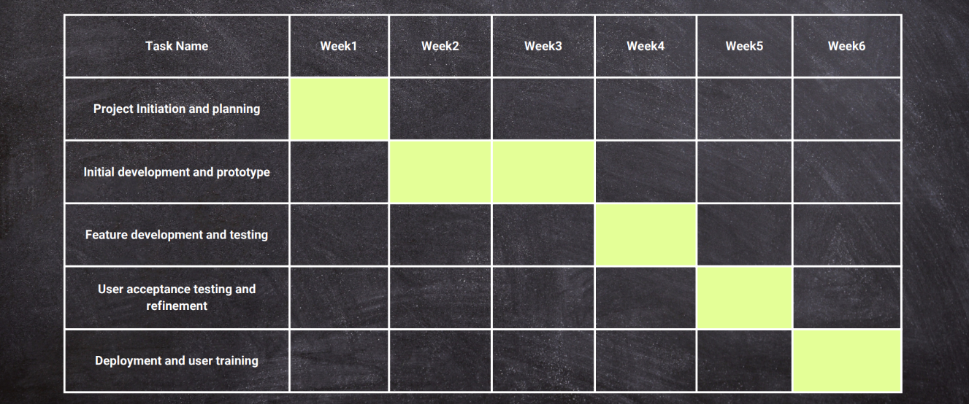

Figure 12: project plan

Source code

Admin controller

<?php

namespace App\Http\Controllers;

use Illuminate\Http\Request;

use App\Models\Service;

use App\Http\Controllers\AdminController;

use App\Models\company;

use App\Models\Appointment;

class AdminController extends Controller

{

public function view_service()

{

return view('admin.service');

}

public function add_service(Request $Request)

{

$service= new service;

$service->service_name=$Request->service_name;

$service->description=$Request->description;

$service->Hours=$Request->hours;

$image=$Request->image;

$imagename=time().'.'.$image->getClientOriginalExtension();

$Request->image->move('service',$imagename);

$service->image=$imagename;

$service->save();

return redirect()->back()->with('message','Service Added Successfully..');

}

public function show_service()

{

$services = service::all();

return view('admin.show_service', compact('services'));

}

public function show_Company()

{

$companies = company::all();

return view('admin.show_company', compact('companies'));

}

public function show_appointments()

{

return view('admin.appointments');

}

public function delete_service($id)

{

$services=service::find($id);

$services->delete();

return redirect()->back()->with('message','Service delete Successfully... ');

}

public function delete_appointment($Vnumber)

{

$appointments=appointment::find($Vnumber);

$appointments->delete();

return redirect()->back()->with('message','Service delete Successfully... ');

}

public function update_service($id)

{

$services=service::find($id);

return view('admin.update_service',compact('services'));

}

public function update_service_confirm(Request $Request,$id)

{

$services=service::find($id);

$services->service_name=$Request->service_name;

$services->Hours=$Request->hours;

$services->description=$Request->description;

$image=$Request->image;

if($image)

{

$imagename=time().'.'.$image->getClientOriginalExtension();

$Request->image->move('service',$imagename);

$services->image=$imagename;

}

$services->save();

return redirect()->back();

}

}

Home controller

<?php

namespace App\Http\Controllers;

use Illuminate\Http\Request;

use Illuminate\Support\Facades\Auth;

use App\Models\user;

use App\Models\Service;

use App\Models\company;

use App\Models\Appointment;

class HomeController extends Controller

{

public function showServicepage()

{

$services = Service::all();

return view('home.userpage', compact('services'));

}

public function showAboutPage()

{

return view('home.about.aboutuserpage');

}

public function index()

{

$services = Service::paginate(3);

return view('home.userpage', compact('services'));

}

public function service_details($id)

{

$services=service::find($id);

return view('home.service_details', compact('services'));

}

public function redirect()

{

$usertype = Auth::user()->usertype;

if($usertype=='1')

{

return view('admin.home');

}

else

{

$services = Service::paginate(3);

return view('home.userpage', compact('services'));

}

}

public function appointment_dts($id)

{

if(Auth::id())

{

$user=Auth::user();

$serivces=serive::find($id);

$appointments=new appointments;

$appointments->service_name=$user->service_name;

$appointments->user_id=$user->name;

$appointments->phone=$user->phone;

}

else

{

return redirect('login');

}

}

public function company_register()

{

return view('home.company');

}

public function add_company(Request $request)

{

$company = new Company;

$company->company_name = $request->company_name;

$company->company_email = $request->company_email;

$company->company_phone = $request->company_phone;

$company->company_address = $request->company_address;

$company->save();

return redirect()->back()->with('message', 'Service Added Successfully..');

}

}

Migrations

<?php

use Illuminate\Database\Migrations\Migration;

use Illuminate\Database\Schema\Blueprint;

use Illuminate\Support\Facades\Schema;

return new class extends Migration

{

/**

* Run the migrations.

*/

public function up(): void

{

Schema::create('services', function (Blueprint $table) {

$table->id();

$table->string('service_name')->nullable();

$table->string('description')->nullable();

$table->string('image')->nullable();

$table->string('Hours')->nullable();

$table->timestamps();

});

}

/**

* Reverse the migrations.

*/

public function down(): void

{

Schema::dropIfExists('services');

}

};

<?php

use Illuminate\Database\Migrations\Migration;

use Illuminate\Database\Schema\Blueprint;

use Illuminate\Support\Facades\Schema;

return new class extends Migration

{

/**

* Run the migrations.

*/

public function up(): void

{

Schema::create('users', function (Blueprint $table) {

$table->id();

$table->string('name');

$table->string('email')->unique();

$table->string('usertype')->default(0);

$table->string('Phone')->nullable();

$table->string('address')->nullable();

$table->timestamp('email_verified_at')->nullable();

$table->string('password');

$table->rememberToken();

$table->foreignId('current_team_id')->nullable();

$table->string('profile_photo_path', 2048)->nullable();

$table->timestamps();

});

}

/**

* Reverse the migrations.

*/

public function down(): void

{

Schema::dropIfExists('users');

}

};

Routes

<?php

use Illuminate\Support\Facades\Route;

use App\Http\Controllers\HomeController;

use App\Http\Controllers\AdminController;

use App\Http\Controllers\TestController;

Route::get('/',[HomeController::class,'index']);

Route::middleware(['auth:sanctum',config('jetstream.auth_session'),

'verified',])->group(function () {Route::get('/dashboard', function () {

return view('dashboard');

})->name('dashboard');

});

Route::get('/redirect',[HomeController::class,'redirect']);

Route::get('/about', [HomeController::class, 'showAboutPage'])->name('about.page');

Route::get('/', [HomeController::class, 'index'])->name('home');

Route::get('/show_appointments',[TestController::class,'show_appointments']);

//Route::get('/service',[AeController::class,'showServicePage']);

Route::get('/servicepage', [HomeController::class, 'showServicepage'])->name('service.page');

Route::get('/view_service',[AdminController::class,'view_service']);

Route::post('/add_service',[AdminController::class,'add_service']);

Route::get('/show_service',[AdminController::class,'show_service']);

Route::get('/show_company',[AdminController::class,'show_company']);

Route::get('/delete_service/{id}',[AdminController::class,'delete_service']);

Route::get('/update_service/{id}', [AdminController::class, 'update_service']);

Route::post('/update_service_confirm/{id}',[AdminController::class,'update_service_confirm']);

Route::get('/service_details/{id}',[HomeController::class,'service_details']);

Route::post('appointment_dts/{id}',[HomeController::class,'appointment_dts']);

Route::get('/company_register', [HomeController::class, 'company_register'])->name('company_register');

Route::post('/add_company',[HomeController::class,'add_company']);

Route::post('add_appointments',[TestController::class,'add_appointments']);

Route::get('/delete_appointment/{Vnumber}',[AdminController::class,'delete_appointment']);<?php

use Illuminate\Support\Facades\Route;

use App\Http\Controllers\HomeController;

use App\Http\Controllers\AdminController;

use App\Http\Controllers\TestController;

Route::get('/',[HomeController::class,'index']);

Route::middleware(['auth:sanctum',config('jetstream.auth_session'),

'verified',])->group(function () {Route::get('/dashboard', function () {

return view('dashboard');

})->name('dashboard');

});

Route::get('/redirect',[HomeController::class,'redirect']);

Route::get('/about', [HomeController::class, 'showAboutPage'])->name('about.page');

Route::get('/', [HomeController::class, 'index'])->name('home');

Route::get('/show_appointments',[TestController::class,'show_appointments']);

//Route::get('/service',[AeController::class,'showServicePage']);

Route::get('/servicepage', [HomeController::class, 'showServicepage'])->name('service.page');

Route::get('/view_service',[AdminController::class,'view_service']);

Route::post('/add_service',[AdminController::class,'add_service']);

Route::get('/show_service',[AdminController::class,'show_service']);

Route::get('/show_company',[AdminController::class,'show_company']);

Route::get('/delete_service/{id}',[AdminController::class,'delete_service']);

Route::get('/update_service/{id}', [AdminController::class, 'update_service']);

Route::post('/update_service_confirm/{id}',[AdminController::class,'update_service_confirm']);

Route::get('/service_details/{id}',[HomeController::class,'service_details']);

Route::post('appointment_dts/{id}',[HomeController::class,'appointment_dts']);

Route::get('/company_register', [HomeController::class, 'company_register'])->name('company_register');

Route::post('/add_company',[HomeController::class,'add_company']);

Route::post('add_appointments',[TestController::class,'add_appointments']);

Route::get('/delete_appointment/{Vnumber}',[AdminController::class,'delete_appointment']);